

Final Project
CPS2232: Data structure and algorithm

Student Name: | Xinyu Chen(Brian)  Yuehan Shi(Daisy)
Student ID: | 1234760  1308366
Lecture: | Dr. Hemn Barzan Abdalla

Final Project: Data structure and algorithm

Motivation
In university teaching management, issues such as scattered course information, the lack of a systematic structure for professor evaluations, and the inconvenience students face when accessing relevant information have long persisted. Students often need to search across multiple sources for course descriptions, professor backgrounds, and past teaching evaluations, which is time-consuming and lacks structured data support. Meanwhile, professors and academic administrators often struggle to obtain timely feedback and comprehensive analyses of teaching quality, hindering effective course improvement and informed decision-making. Therefore, it is essential to develop an efficient, unified, and well-structured platform for managing and retrieving information on courses and professors.
The goal of this system is to provide a reliable and user-friendly platform for course and professor evaluation, enabling students to conveniently access course details, professor profiles, and evaluation records, thereby making more informed course-selection decisions. In this system, we choose three data structures, namely List, Map, and AVL Tree, to store data. We manage and retrieve data through the unique attributes and operation of these three data structures. At the same time, the system offers professors and academic administrators real-time analytical capabilities—such as average course ratings and professor performance rankings—which help support teaching improvement and resource allocation. Furthermore, by integrating algorithms such as linear search, binary search, and insertion sort, the system demonstrates the practical application of fundamental data structures and algorithms in a real-world educational information platform.
In summary, the development of this system not only enhances the transparency and accessibility of teaching-related information but also promotes continuous improvement in teaching quality. It lays a solid foundation for building a more efficient and intelligent university information management environment.
Data Structures Usage
- HashMap
- HashMap<String, Course> courseMap
Key: Course ID, for example "CPS1231"
Value: Corresponding Course object
- HashMap<String, Professor> professorMap
Key: Professor’s name, for example "Alice"
Value: Corresponding Professer object
- List
- List<CourseProfessor> teaching: For each profeesor, use List<CourseProfessor> to store the list of courses taught by the professor along with their evaluation information.
- List<CourseProfessor> professorList: For each course, use List<CourseProfessor> to store the list of all professors teaching this course and their ratings.
- List<Rating> ratingList: Save the complete score records and comments of a certain professor for a particular course.
- AVL Tree
- CourseAVLTree courseTree: In the rating system, AVL Tree is to store courses for sorting by name with a fast way.

Data Structures Usage Reasons
- courseAVLTree (AVL Tree)
Advantages:
- The self-balancing property guarantees that the tree height remains O(log n).
- Insert, delete, and search operations all run in O(log n) time.
- In-order traversal naturally produces a course list sorted by name.
- Shows clear performance advantages over linear search when data volume is large.
Usage in This System:
- Stores all courses in lexicographical order based on course name.
- Performs fast keyword search on course names.
- Enables efficient filtering of courses by initial letter.
- Supports retrieving a sorted list of courses through in-order traversal.
- Add course function code show
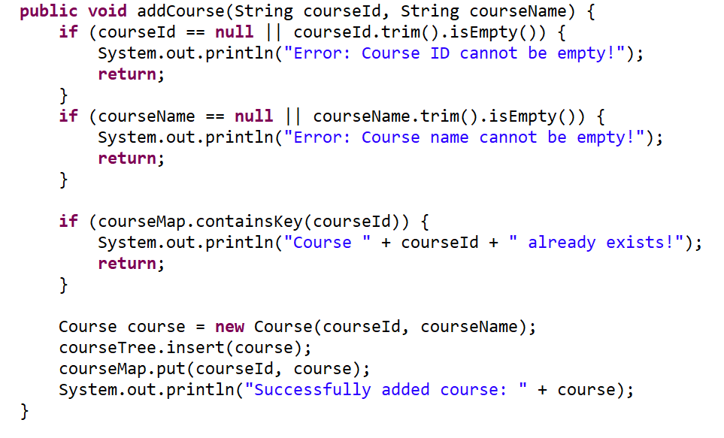
- courseMap/professorMap (HashMap)
Advantages：
- Average lookup time complexity is O(1), making it ideal for frequent “exact lookup by course ID” operations.
- The key–value structure is clear, easy to maintain, and easy to extend.
Usage in This System：
- Quickly locates the corresponding Course object when the user inputs a course ID.
- teaching (List<CourseProfessor>)
Advantages：
- Supports one professor teaching multiple courses (many-to-many relationship)
- Easy to update: teaching.add(newCourse)
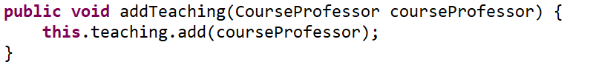
Usage in This System:
- Displays all courses taught by a professor when performing professor search.
- Maintains a “one professor to many courses” relationship between courses and professors.
- Used to compute: Number of courses a professor teaches and overall average rating.
- professorList (List<CourseProfessor>)
Advantages:
- Supports many professors per course (many-to-many relationship).
- Easy traversal of professor data.
- Useful for displaying the list of professors along with their average ratings on a course page.
Usage in This System:
- Maintains the “one course having many professors” relationship inside the Course class.
- Supports adding new professors and querying professor’s information.
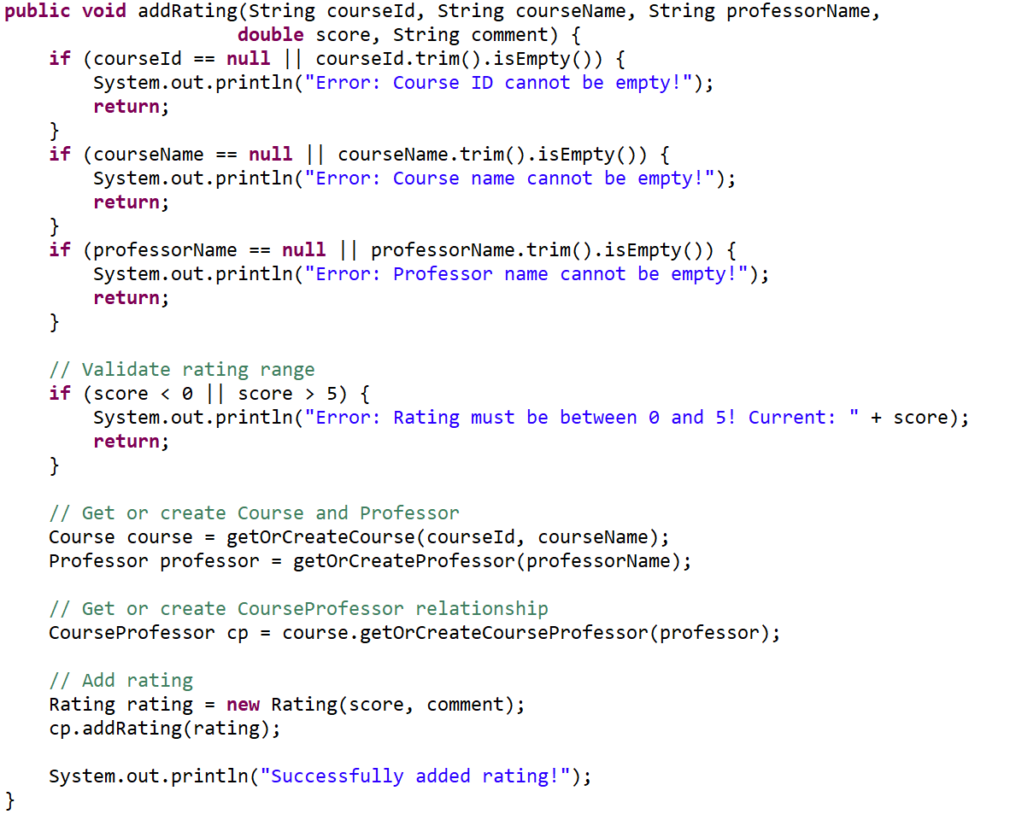
- Sorting by average score can be added later using Collections.sort().
- ratingList (List<Rating>)
Advantages:
- Easy to traverse: Functions fast computation of: average score, highest and lowest ratings, total number of ratings.
- Fast insertion: New ratings can be appended with O(1) time complexity.
- Allows repeated entries: multiple ratings for the same course–professor pair can be stored.
Usage in This System:
- Stores all ratings for each professor in a specific course.
- Displays all user comments when viewing course details.
- Provides the data basis for calculating a professor’s average rating for ranking.

Algorithms
- AVL Tree Algorithms (Used for Course Storage and Search)
Basic Principles
- An AVL Tree is a self-balancing binary search tree.
- The height difference between left and right subtrees of any node is at most 1.
- Balance is maintained through tree rotations.
Rotation Operations
- Left Rotation: used when the right subtree is too high.
- Right Rotation: used when the left subtree is too high.
- Left–Right Rotation: left rotation followed by right rotation.
- Right–Left Rotation: right rotation followed by left rotation.
Course Search Algorithms
- Search by Course Name Keyword: Leverages AVL Tree ordering for optimized searching and performs pruning based on comparisons.
- Search by Initial Letter: Uses lexicographical ordering of course names to quickly locates the range within the AVL Tree.
- Hash Search (For Course ID and Professor Name)
- In HashMap, exact lookup by course ID or professor name.
- Implementation: use get(key) directly.
- Insertion Sort (For Professor Ranking Within a Course)
- Purpose: When a new professor is added to a course or an existing professor's rating changes, the system updates the ordering of professors based on average rating in real time.
- Data Structure: List<CourseProfessor>
- Procedure: Assume professorList is already sorted by rating (high to low). When a professor is added or updated. Insert the new/updated CourseProfessor into the list. Starting from the index of the new entry, compare backward to find the correct insertion position. Shift elements one by one to make space. If updating, remove the old record first, then reinsert
- Sort Profesor Code show
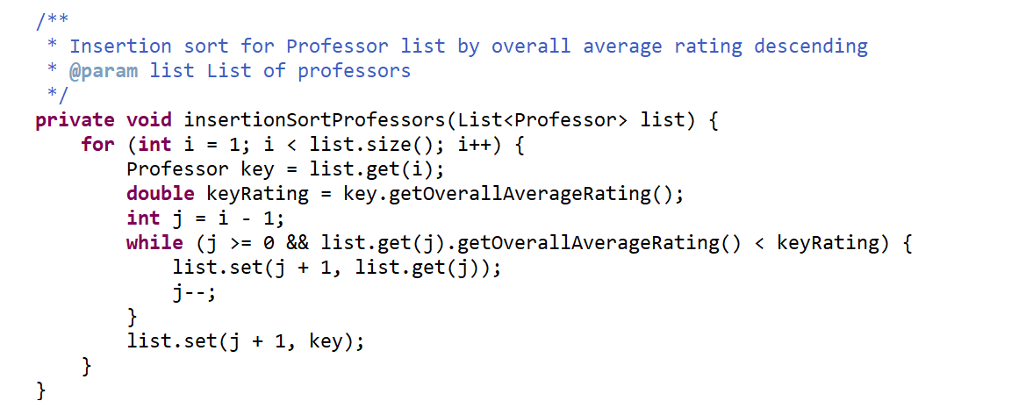

Time Complexity Summary
Operation | Data Structure | Time Complexity
Search by Course ID | HashMap | O(1)
Search by Professor Name | HashMap | O(1)
Insert Course | AVL Tree | O(log n)
Search Course by Name | AVL Tree | O(log n)
Search Course by Keyword | AVL Tree | O(log n + k)(k is the number of searching results)
Search Course by Initial Letter | AVL Tree | O(log n + k)(k is the number of searching results)
In-order Traversal (Sorted Course List) | AVL Tree | O(n)
AVL Tree Rotation | AVL Tree | O(1)
Sort Professors in a Course | Insertion Sort on List | O(n²)
Compute Average Rating | Traverse List | O(n)

Class Design
UML
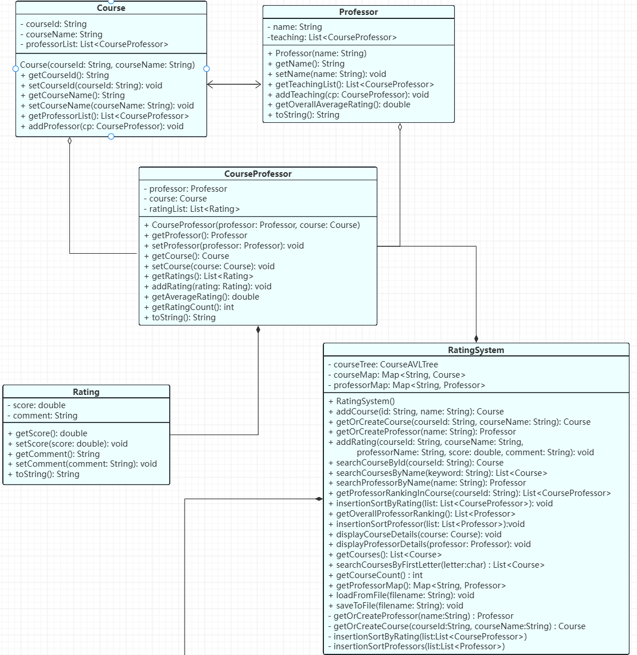
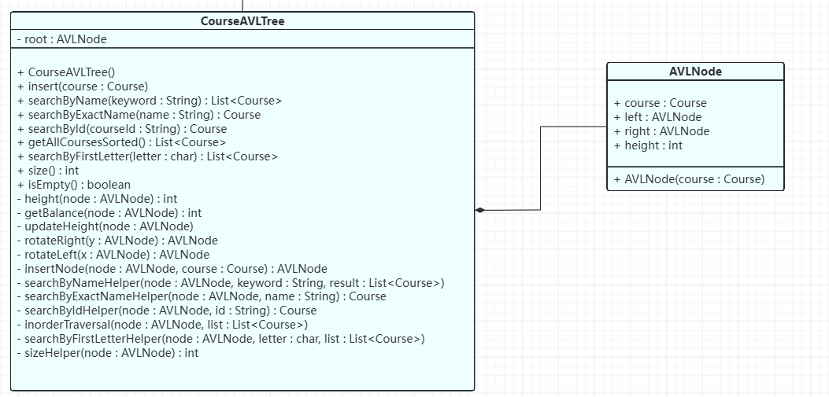
User Interface
- Interaction Method
The system uses a Command-Line Interface (CLI) for user interaction. Users operate the system by selecting menu options and entering text-based inputs.
- Menu Structure Example
===== Course & Professor Rating System =====
1. Load data from file
2. Add new course
3. Add new rating
4. Search by course ID
5. Search by course name (keyword)
6. Search by professor name
7. Show professor ranking
8. Save data to file
0. Exit
Please choose an option:
- Example Interaction Workflow
The user selects a menu item.
The system prompts for input (keywords, course ID, professor name, rating, or comments).
The program processes the request and outputs relevant information, such as: Course details, Professor profiles, Average ratings, Ranking results, User-entered comments and scores.
Input and Output
- Input File Format: The system loads data from a CSV file where each line represents a single rating entry, courseId, courseName, professorName, rating,comment.
Example input:
CPS1231,Java Programming,Dr. Smith,4.5,Very clear explanation
MATH2413,Calculus I,Dr. Lee,3.8,Homework is heavy
...
- File Reading Process
When loading data: Use BufferedReader to read the file line by line. Use split(",") to parse fields. Based on courseId, courseName, and professorName: Retrieve existing objects or create new ones as needed. Create a Rating object using the score and comment. Add the rating to the corresponding course–professor relationship.
- File Saving Process
When saving data: Traverse all courses in the system.For each course, iterate through its associated professors. For each professor, iterate through all ratings. Write one CSV line for each rating.
Example output:
CPS1231,Java Programming,Dr. Smith,4.5,Very clear explanation
MATH2413,Calculus I,Dr. Lee,3.8,Homework is heavy
...

